FBE Architecture Document

Contents
- Server Architecture
- Application Architecture
- Sequence Diagrams
  - Product update(like name, description)
  - Inventory Allocation for channels from FBE
  - Product Inbound
  - Product Outbound
- Technology Stack

- Server Architecture

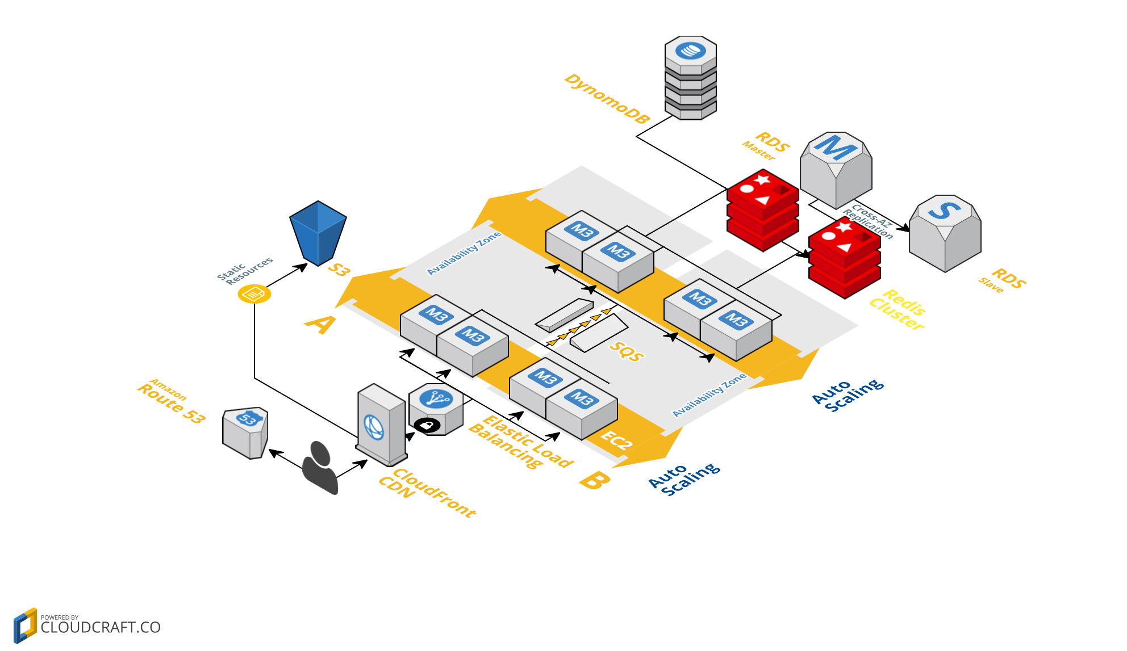

- Application Architecture
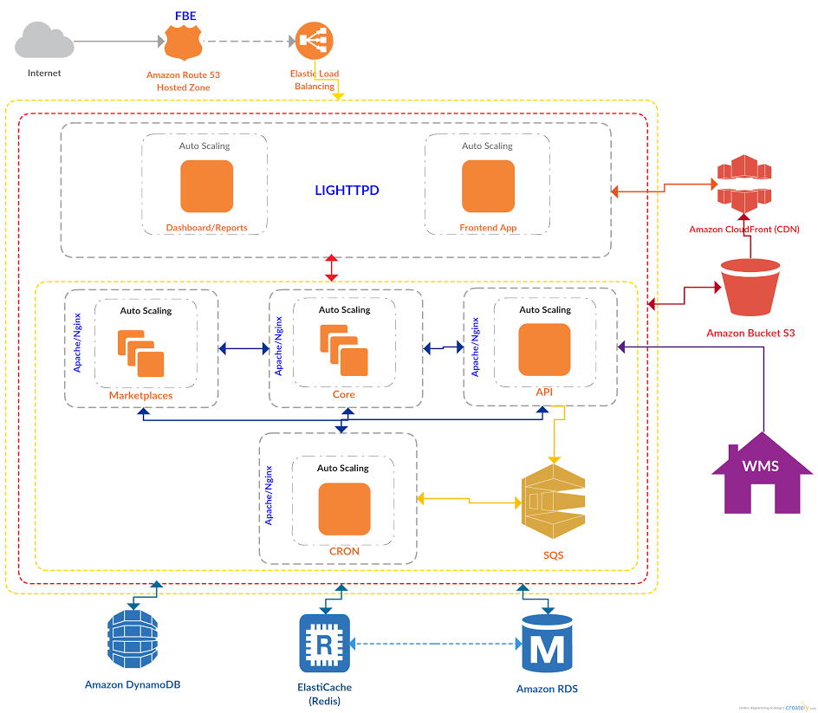
- Sequence diagrams
  - Product update(like name, description)
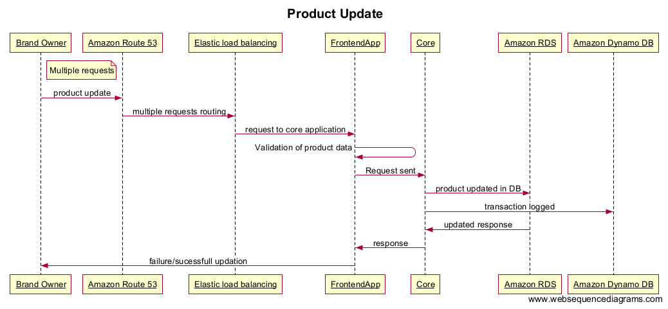
- Products information updated by brand owner in FBE portal.
- Concurrent requests from sellers will be sent to Amazon Route 53 via Elastic load balancing to FrontendApp.
- Data validation done at FrontendApp and valid information sent to core level. Reponses will send back to frontendapp to seller.
- From core product updated in Amazon RDS, transactions are logged in Amazon Dynamo DB.

  - Inventory Allocation for channels from FBE

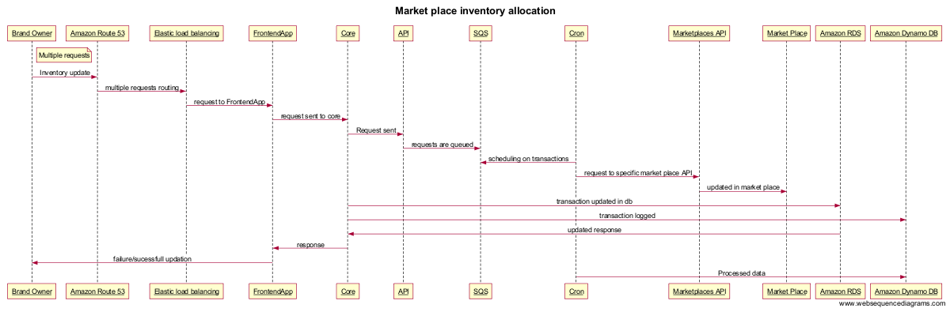

- Inventory allocation for a market place is changed by seller/brand owner.
- Concurrent requests from sellers will be sent to Amazon Route 53 via Elastic load balancing to FrontendApp.
- From frontendApp request will be sent to core, core to API and from API request will be sent to SQS.
- Cron will fetch queued task and will send request to Market place API, from market place API it will call market place.
- From Core data will be stored in Amazon RDB and transactions are logged in Amazon Dynamo DB.

  - Product Inbound
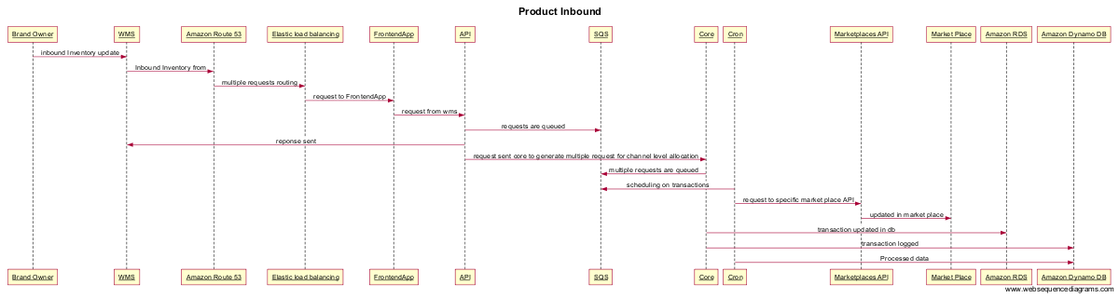

- Product quantity inbounded by seller at warehouse, WMS will send an inbound request to FBE API via Amazon Route 53,
Elastic load balancing and frontendApp.
- FBE API will send the response back to WMS and queue the request in SQS.
- API will send a request to Core to trigger market place API based on percentage allocation change.
- Requests generated from Core will be queued in SQS, cron will pull request and send them to Market places.
- Changes allocation percentage will be updated in Amazon RDB.
  - Product Outbound
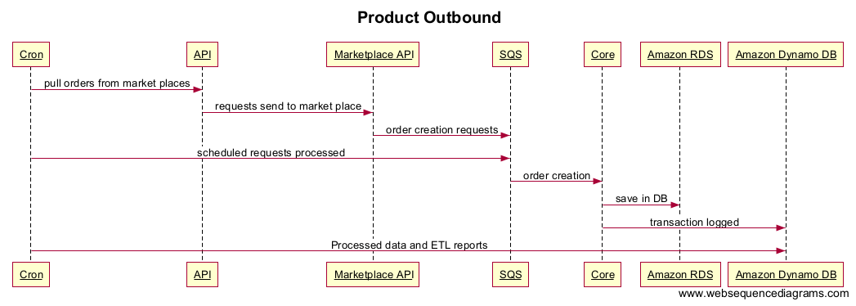

- FBE cron on scheduled interval will request API and from API requests will be sent to Market place API.
- Order creation requests are queued in SQS from Market place API.
- Cron schedule based orders will be created in Core; same will be saved in Amazon RDS.
- All transactions are logged in Amazon Dynamo DB.

- Technology Stack
Technologies for FBE:
- PHP 5.6
- Laravel 5.2
- Mysql 5.0
- Jquery
- Angular Js (Evaluating)
- Node Js (Evaluating)
- Quartz(Evaluating)

